Basic editing: Editing text labels
NOTE: Labels may only be edited according to the input method used to create them. For example, a text label entered via braille (six-key) input may only be edited using six-key, and a raised print character label may only be edited as a raised print character label. Labels can’t be converted from one type of label to another.
Changing how labels are viewed (computer or braille keyboard entry text labels)
To view only the text of the labels in your document, select a text label and then choose the Hide Braille Dots on Screen icon 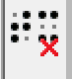 from the tool bar on the left side of the screen, or right-click a text label and select the Hide braille dots on screen option from the context menu. To show the braille dots again, select a text label and choose the Show Braille Dots on Screen icon 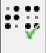 from the tool bar on the left side of the screen, or right-click a text label and select the Show braille dots on screen option from the context menu.
To make other changes to how your text labels are shown and/or printed, please refer to the Advanced Preferences and Setup tutorial. NOTE: Hiding the braille dots does not hide the braille in mammoth braille labels.
Cutting, copying, pasting and deleting labels (all label types)
The fastest way to copy, cut, paste or delete a label is using hotkeys. To cut a label, select it and press CTRL+X on the keyboard. Cutting the label removes it from the file but remembers it so you can paste it somewhere else in the file. The cut label can only be pasted until you cut or copy a different label or object. To copy a label, select it and press CTRL+C. Copying leaves the original label but keeps a copy of it that you can paste somewhere else in the file. To paste a cut or copied label, press CTRL+V. To delete a selected label, press the Delete key on the keyboard.
Moving labels (all label types)
Once your label is selected, you can move it by clicking the center and dragging it to a new position. You can also easily move the label to the center of the design area by right-clicking it and selecting Center from the context menu, or move it only horizontally or only vertically by right-clicking it, selecting Move the label or object only horizontally or vertically and then dragging it up or down to move it vertically without changing its horizontal position or left or right to move it horizontally without changing its vertical position.
Resizing labels (mammoth braille labels and raised print character labels only)
NOTE: Because braille is a fixed size, text labels created using either computer keyboard entry or braille keyboard entry may not be resized.
You can resize a mammoth braille label in one of two ways. The first way is to scale a mammoth braille label manually. To do this, select it, then click a purple square in one of the corners of the label and drag it diagonally until the label is the desired size. This resizes the mammoth braille inside the label to fit the new label size. The other way to resize a mammoth braille label is to right-click it and choose Braille dot size, which brings up a dialog on which you can specify the size of the mammoth braille relative to standard braille as a percentage. The default percentage is 300, which means the mammoth braille is three times larger than standard braille. Enter the desired size of the mammoth braille and choose OK to close the dialog, adjust the mammoth braille size and automatically resize the label to fit the new size of the mammoth braille.
Raised print character labels may also be resized in one of two ways. The first way is the same as for mammoth braille labels; select the raised print character label, then click a purple square in one of the corners of the label and drag it diagonally until the label is the desired size. This resizes the raised print characters inside the label. The other way is to right-click the raised print character label and choose Font type and size from the context menu. This launches a dialog that allows you to choose any font on your computer for the label, to specify any available font style for that font and to define the desired font size. Once you have finished making selections, choose OK on this dialog to apply your choices to the label text. The raised print character label will be resized to fit the new size of the text.
Rotating labels (all label types)
To rotate a label, right-click it and then choose Rotation from the context menu. On the dialog that appears, enter the desired angle of rotation in degrees and choose OK to rotate the label. You can also use the scroll wheel on a mouse to rotate a selected label.
Editing text label content
Text labels may only be edited using the same entry method with which they were created (computer keyboard entry or braille keyboard entry. To edit the content of the computer keyboard entry text label, click the label to place the cursor in the text and edit the content as desired, or right-click the label and choose Text and position: computer keyboard input to bring up the text and position dialog you used to create the label originally, make the desired changes and choose OK to update the text in the label.
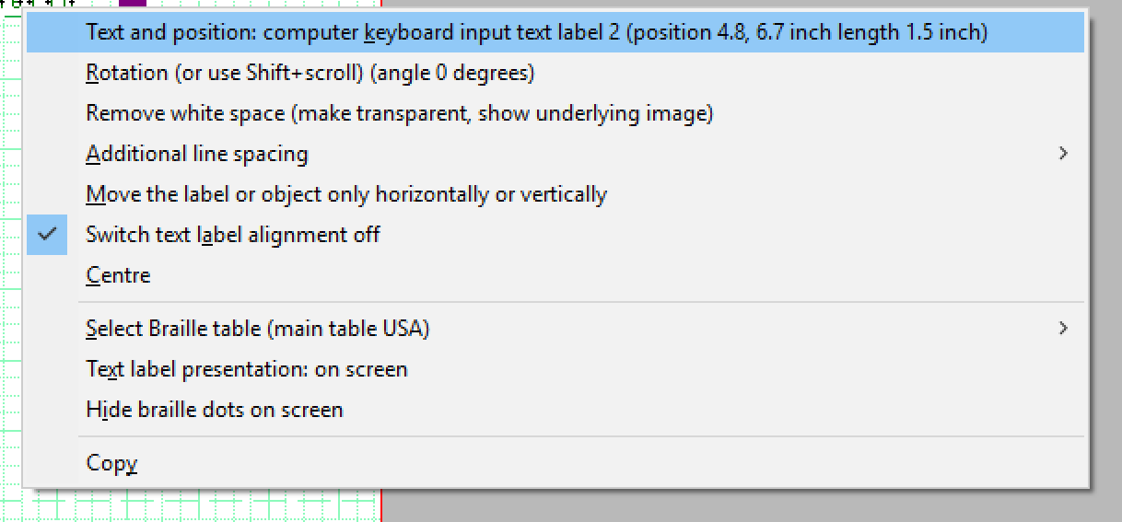
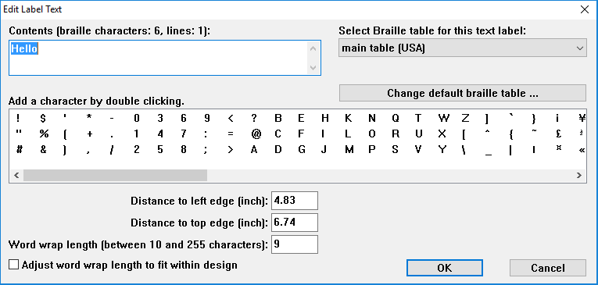
To edit the content of a braille keyboard (six-key) entry label, right-click it and choose Text and position: braille keyboard input to bring up the text and position dialog you used to create the label. Edit the label content as desired using six-key entry. When you’re finished, choose OK to close the dialog and update the label.
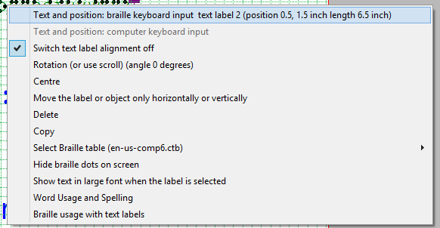
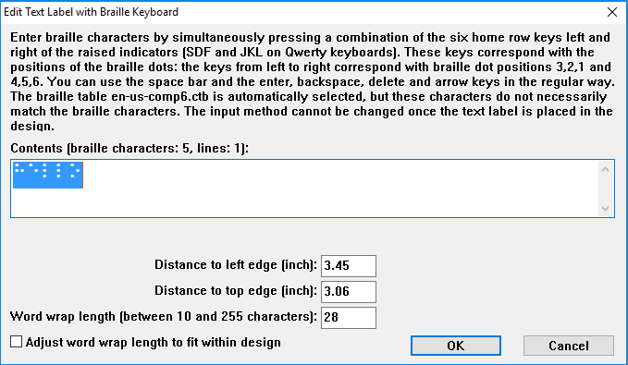

Editing mammoth braille label content
To edit the content of a mammoth braille label, right-click it and choose ‘Text’ and position mammoth braille to bring up the text and position dialog you used to create the label. Edit the label content as desired, then choose OK to close the dialog and update the label.
Editing raised print character label content
To edit the content of a raised print character label, right-click it and choose Text and position: letters/digits to bring up the text and position dialog you used to create the label. Edit the label content as desired, then choose OK to close the dialog and update the label.

For more information about the TactileView program, visit www.dreamvisiongroup.org

